Lecture # 26:

Objective:

* EMAIL using SMTP Protocol

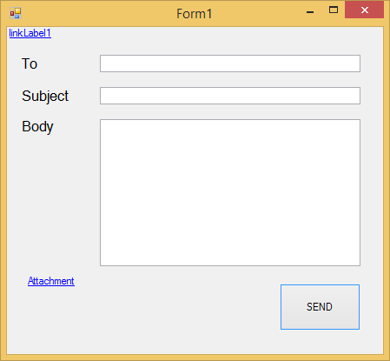

using System;

using System.Collections.Generic; using System.ComponentModel; using System.Data;

using System.Drawing; using System.Linq; using System.Text;

using System.Windows.Forms; using System.Net;

using System.Net.Mail;

namespace emailExample

{

public partial class Form1 : Form

{

public Form1()

{

InitializeComponent();

}

private void button1_Click(object sender, EventArgs e)

{

MailMessage mail = new MailMessage();

mail.From = new MailAddress(["youreamil@gmail.com"](mailto:youreamil@gmail.com)); mail.To.Add(textBox1.Text);

mail.Subject = textBox2.Text; mail.Body = textBox3.Text;

Attachment at = new Attachment("filePath"); mail.Attachments.Add(at);

SmtpClient sc = new SmtpClient("smtp.gmail.com", 587); sc.Credentials = new

NetworkCredential(["youremAIL@gmail.com"](mailto:youremAIL@gmail.com), "Emailpassword"); sc.EnableSsl = true;

sc.Send(mail);

}

}

}